**Gorgeous Cupcakes**

**Prepared by: Jacob Coorey (Student#:5102810816)**

**Date: 2/17/2017**



Contents

Task 1 2

Task 2 2

# Task 1

Reverse engineer the database structure, display in a designer tool the relationships between the tables of Gorgeous Cupcakes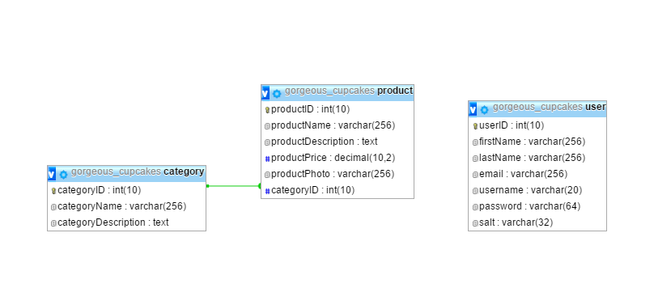

# Task 2

Error / Passed

The registration form functions correctly i.e. a new user can register an account and all user details are stored in the appropriate database table/s.   
Passed

An appropriate error message is displayed on the registration page if the submitted registration details are not valid e.g. required fields are blank, password is less than eight characters, and email is invalid. Passed

The login form functions correctly i.e. a user can login in using a valid username and password that is stored in the appropriate database table.  
Passed

An appropriate error message is displayed on the login page if incorrect login credentials are entered.  
Passed

All authorised pages are inaccessible without login.  
Passed

All product data is extracted from the appropriate database table/s and displayed correctly on the product page.  
Passed

Product data is extracted from the appropriate database table/s and displayed in the correct category on the category page.  
Passed

An existing product can be updated via the product update form and the data is updated in the appropriate database table/s.  
Passed

A new product can be added via the add product form and the data is inserted into the appropriate database table/s.  
Passed

An existing product can be deleted via the website interface and the data is deleted from the appropriate database table/s.  
Passed

# Task 3

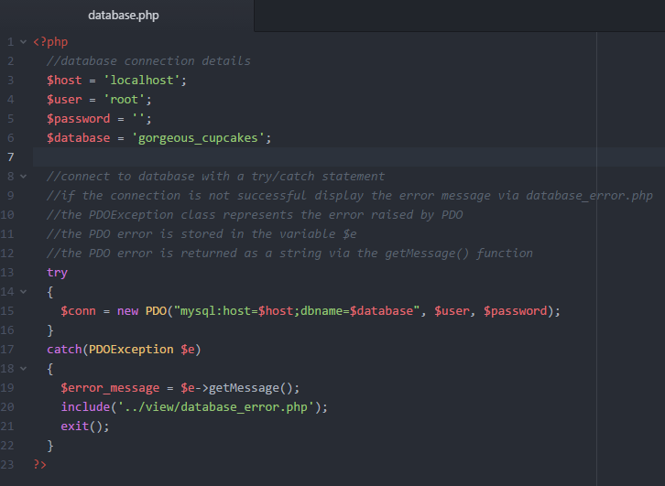

# Task 4

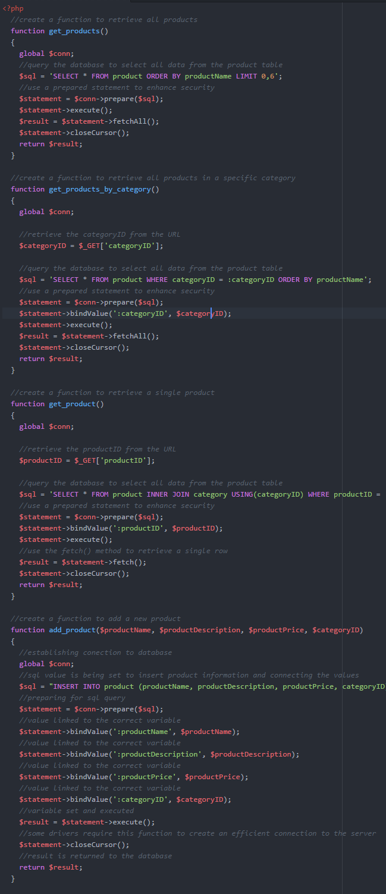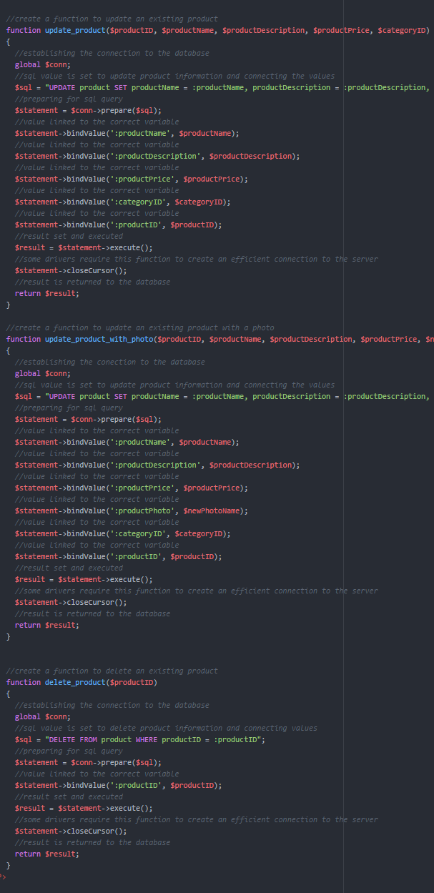

# Task 5

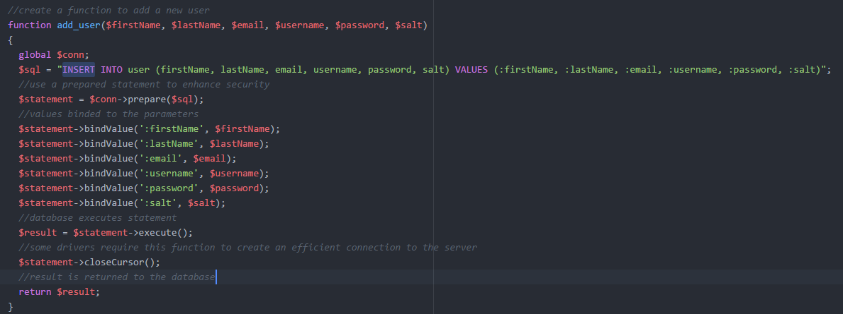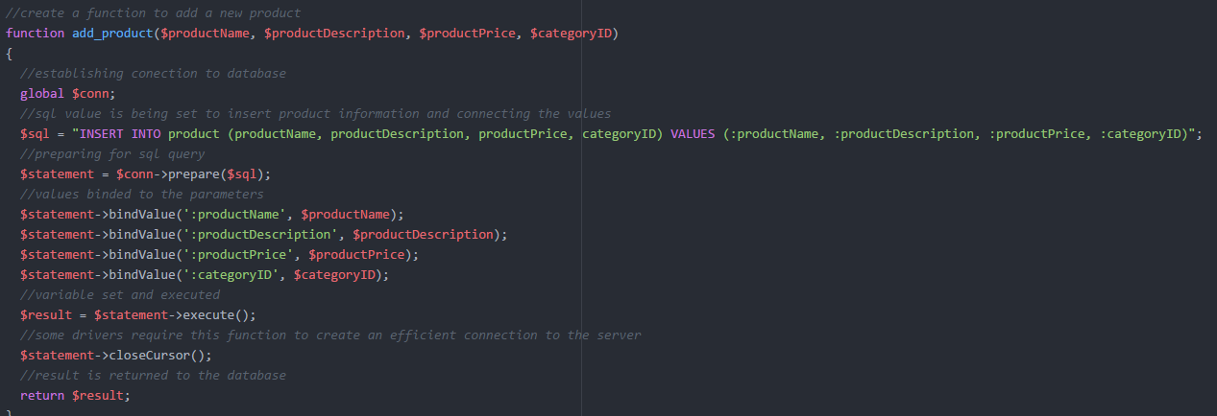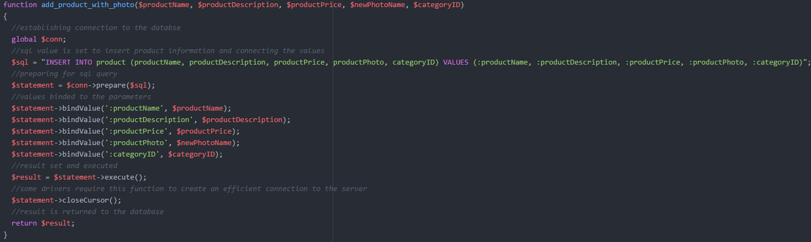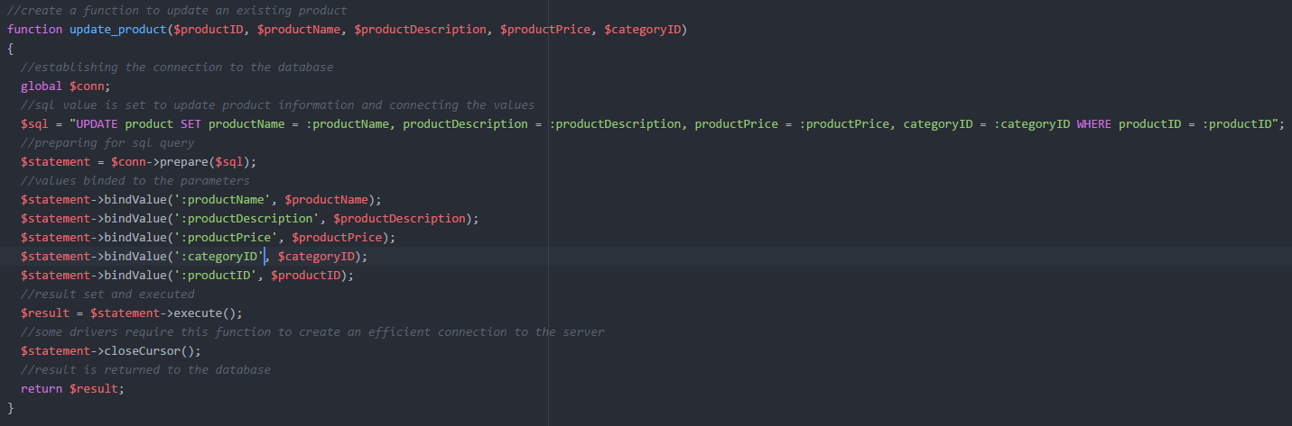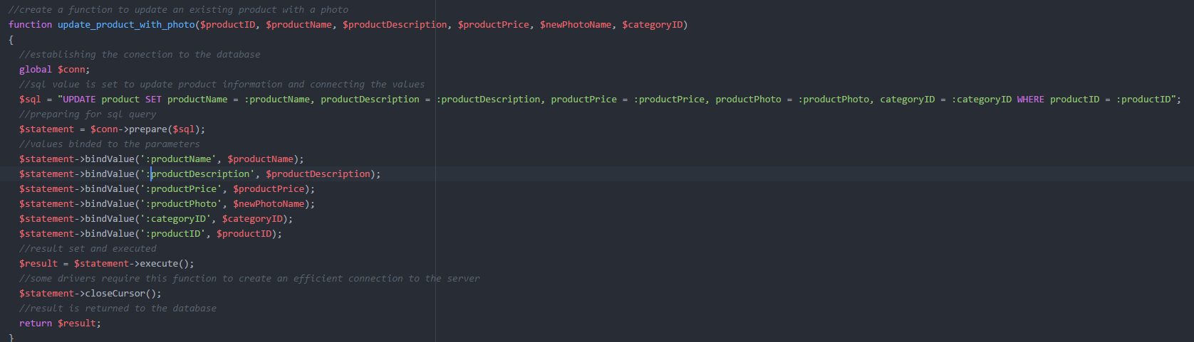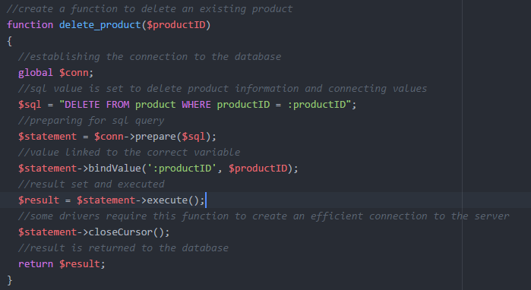

# Task 6

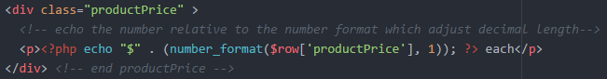

# Task 7



Returns a string formatted according to the given format string using the given integer timestamp or the current time if no timestamp is given. In other words, timestamp is optional and defaults to the value of time()

# Task 8